**Home Page: search icon is displayed incorrectly.**

**Steps to reproduce:**

1. Open the home page. Pay attention to the search element.

**Actual result:** The icon is higher than the search field (screenshot 1.1).

**Expected result:** The icon should be on the same level with the search field..

**Environment:**

1. Os: Windows 10;
2. Browser: Google Chrome 86.0.4240.183, Yandex 20.9.3.136, Microsoft Edge 86.0.622.63

**Severity:** Trivial.

**Priority:** Low.

**Attachment:**

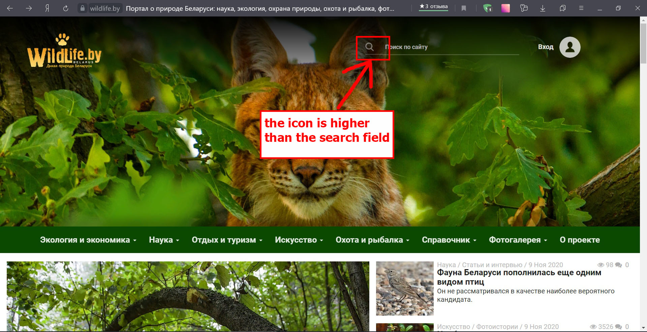

## Home page: link to VK is too wide.

**Steps to reproduce:**

1. Open the home page.
2. Scroll down.
3. Click on "We are in VK". Pay attention to the bottom menu.

**Actual result:** The link is very wide and fits under the rest of the menu (screenshot 2.1).

**Expected result:** Same size as the Facebook link (screenshot 2.2).

**Environment:**

1. Os: Windows 10;
2. Browser: Internet Explorer 11.1139.18362.0

**Severity:** Trivial.

**Priority:** Low.

**Attachment:**

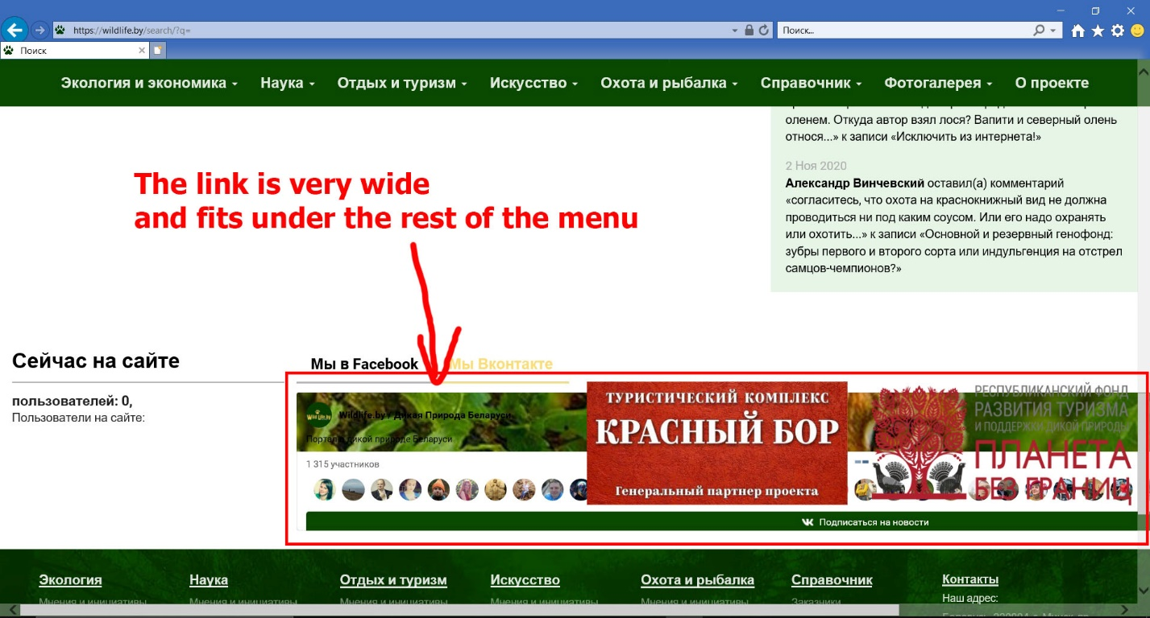

## Photo stories: pictures are not displayed correctly.

**Steps to reproduce:**

1. Open the home page.
2. Select "Photo Stories" from the "Art" menu.
3. Click on "Antonov apples".
4. Scroll down and pay attention to the image.

**Actual result:** The pictures are very wide and will fit under the side menu (screenshot 3.1).

**Expected result:** Pictures should be as wide as text (screenshot 3.2).

**Environment:**

1. Os: Windows 10;
2. Browser: Internet Explorer 11.1139.18362.0

**Severity:** Trivial.

**Priority:** Low.

**Attachment:**

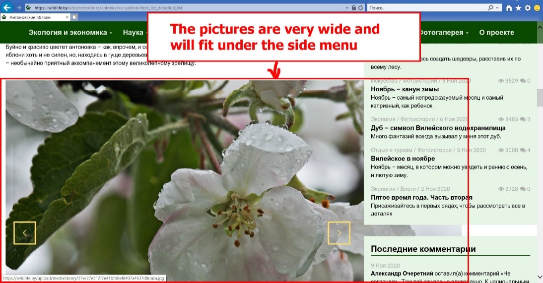

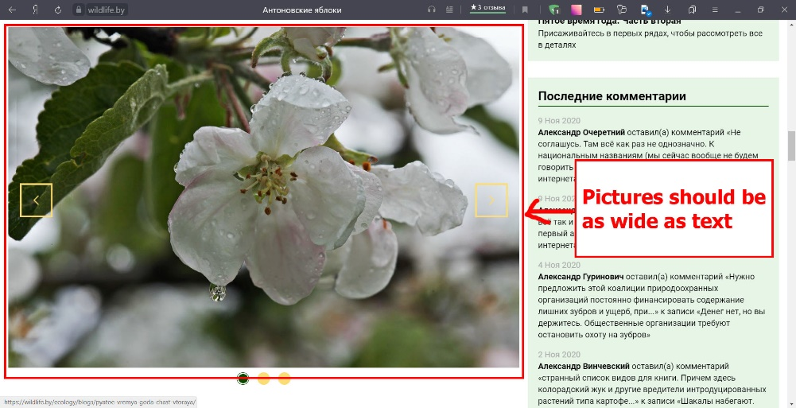

**Art page: the "Viewed" icon has slid down, when text is long.**

**Steps to reproduce:**

1. Open the home page.
2. Choose "Art" and pay attention to the "Viewed" icon in the news feed.

**Actual result:** The "Viewed" icon has slid down (screenshot 4.1).

**Expected result:** Icons are displayed at the same level.

**Environment:**

1. Os: Windows 10;
2. Browser: Internet Explorer 11.1139.18362.0, Google Chrome 86.0.4240.183, Yandex 20.9.3.136

**Severity:** Trivial.

**Priority:** Low.

**Attachment:**

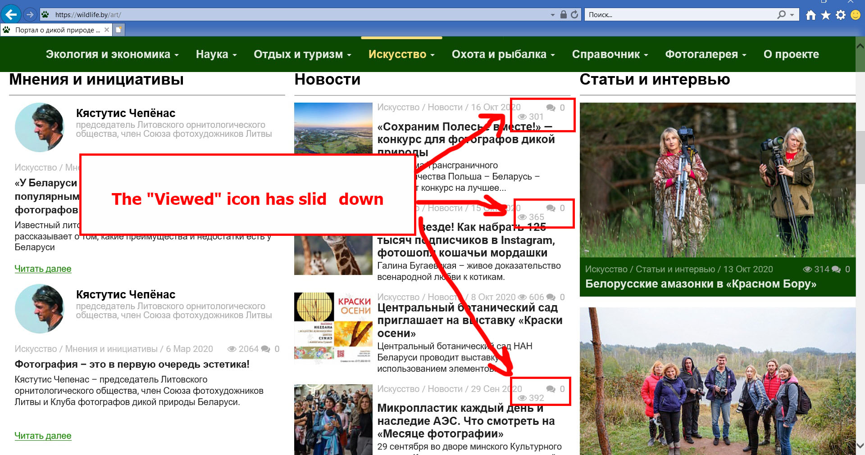

**Home page: the header "blinks" when scrolling.**

**Steps to reproduce:**

1. Open the home page.
2. Scroll down and pay attention to the header.

**Actual result:** The header "blinks" when scrolling down (Header.mp4).

**Expected result:** The header should be hidden when scrolling or remain locked.

**Environment:**

1. Os: Windows 10;
2. Browser: Internet Explorer 11.1139.18362.0

**Severity:** Trivial.

**Priority:** Medium.

**Attachment:**

**Photo gallery "Krasny Bor": the checkbox is not aligned with the top.**

**Steps to reproduce:**

1. Open the home page.
2. Select "Red Forest" in the "Photo Gallery" menu. Pay attention to the "Nature and Man" checkbox in "Categories".

**Actual result:** The checkbox is located to the left of the top (screenshot 6.1).

**Expected result:** All checkboxes should be aligned relative to each other (screenshot 6.2).

**Environment:**

1. Os: Windows 10;
2. Browser: Internet Explorer 11.1139.18362.0

**Severity:** Trivial.

**Priority:** Low.

**Attachment:**

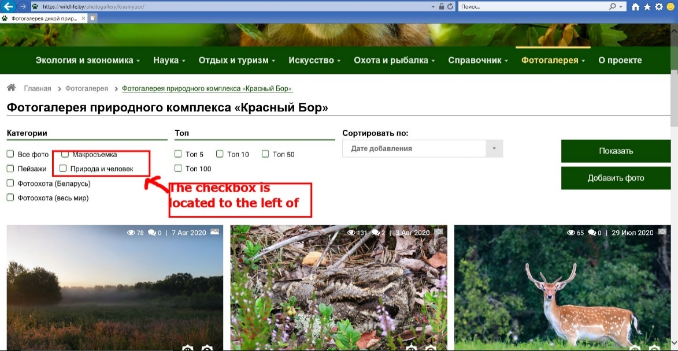

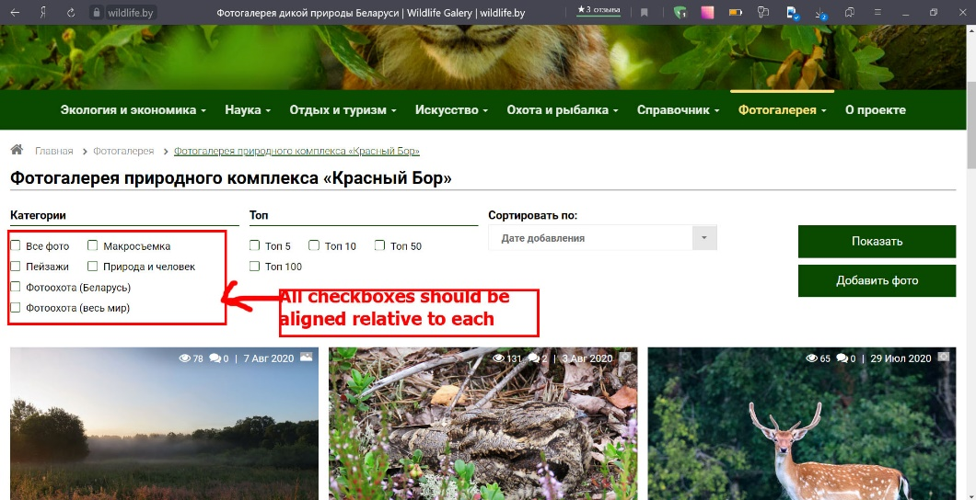

**Photo stories: the word "photo" was added to the link.**

**Steps to reproduce:**

1. Open the home page.
2. Select "Photo Stories" from the "Ecology and Economics" menu.
3. Click on "Civilization under our eyes".
4. Scroll down and pay attention to the link after the photo.

**Actual result:** The word photo is included in the link (screenshot 7.1).

**Expected result:** The word photo should be text (screenshot 7.2).

**Environment:**

1. Os: Windows 10;
2. Browser: Internet Explorer 11.1139.18362.0, Google Chrome 86.0.4240.183, Yandex 20.9.3.136, Microsoft Edge 86.0.622.63

**Severity:** Trivial.

**Priority:** Low.

**Attachment:**

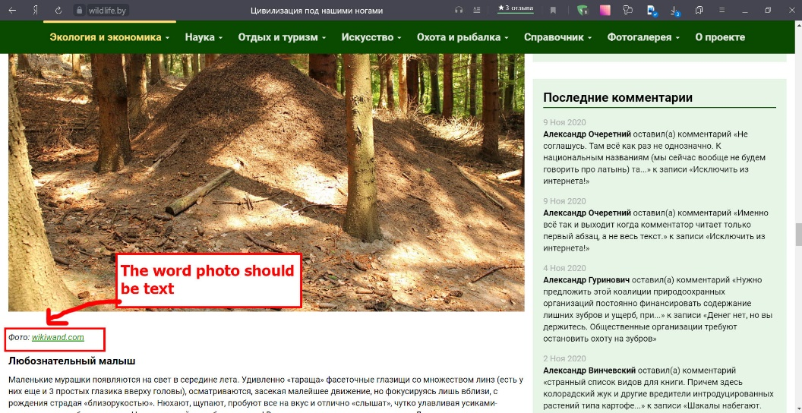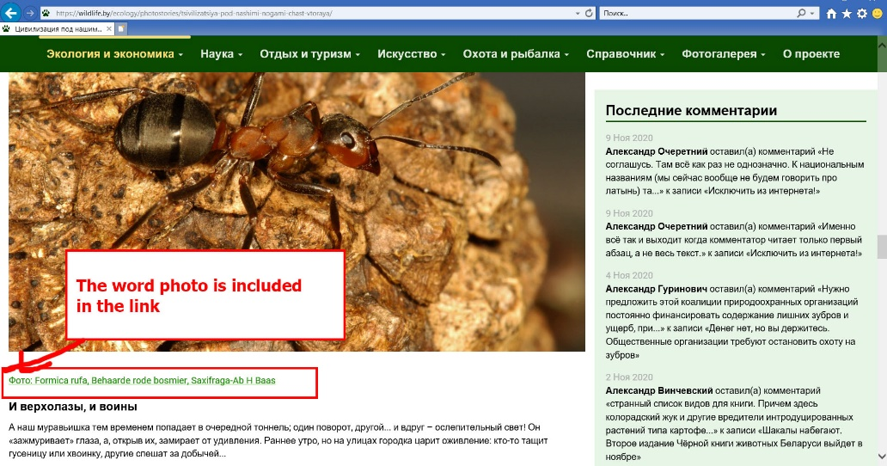

**Opinions and Initiatives: Icons almost blend in with the text, when text is long.**

**Steps to reproduce:**

1. Open the home page.
2. Select "Opinions and Initiatives" from the "Environment and Economics" menu. Pay attention to the icons "viewed" and "number of comments".

**Actual result:** The icons almost merge with the text (screenshot 8.1).

**Expected result:** Icons should be separated from text.

**Environment:**

1. Os: Windows 10;
2. Browser: Internet Explorer 11.1139.18362.0, Google Chrome 86.0.4240.183, Yandex 20.9.3.136, Microsoft Edge 86.0.622.63

**Severity:** Trivial.

**Priority:** Low.

**Attachment:**

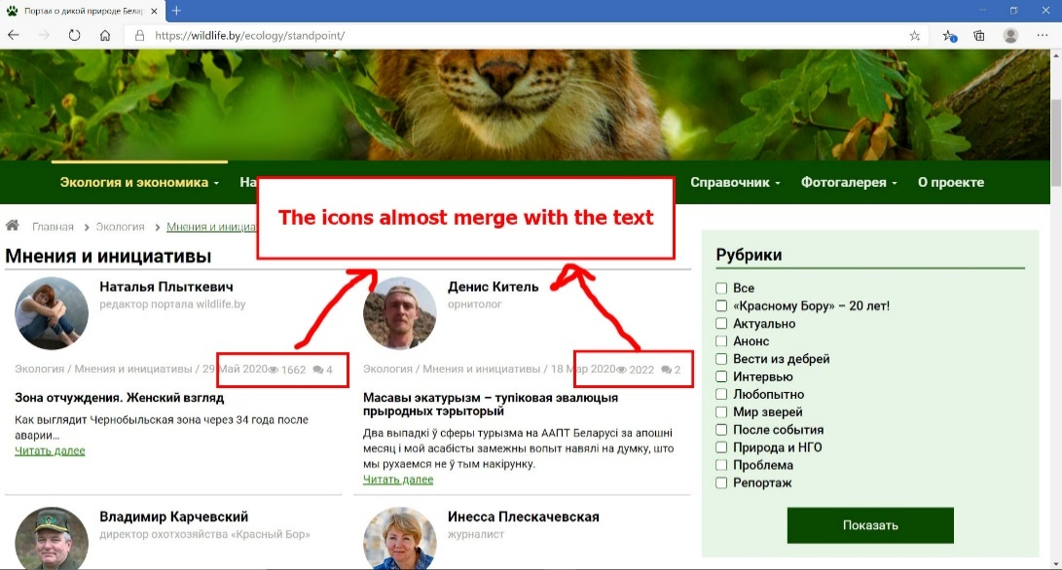

**My photos: the hint will fit on the text.**

**Steps to reproduce:**

1. Open the link <https://wildlife.by/profile/my-photo/>.
2. Pay attention to the hint "Please, log in"

**Actual result:** The hint "Please, log in" will fit on the text (screenshot 9.1).

**Expected result:** The hint should be below.

**Environment:**

1. Os: Windows 10;
2. Browser: Internet Explorer 11.1139.18362.0, Google Chrome 86.0.4240.183, Yandex 20.9.3.136, Microsoft Edge 86.0.622.63

**Severity:** Trivial.

**Priority:** High.

**Attachment:**

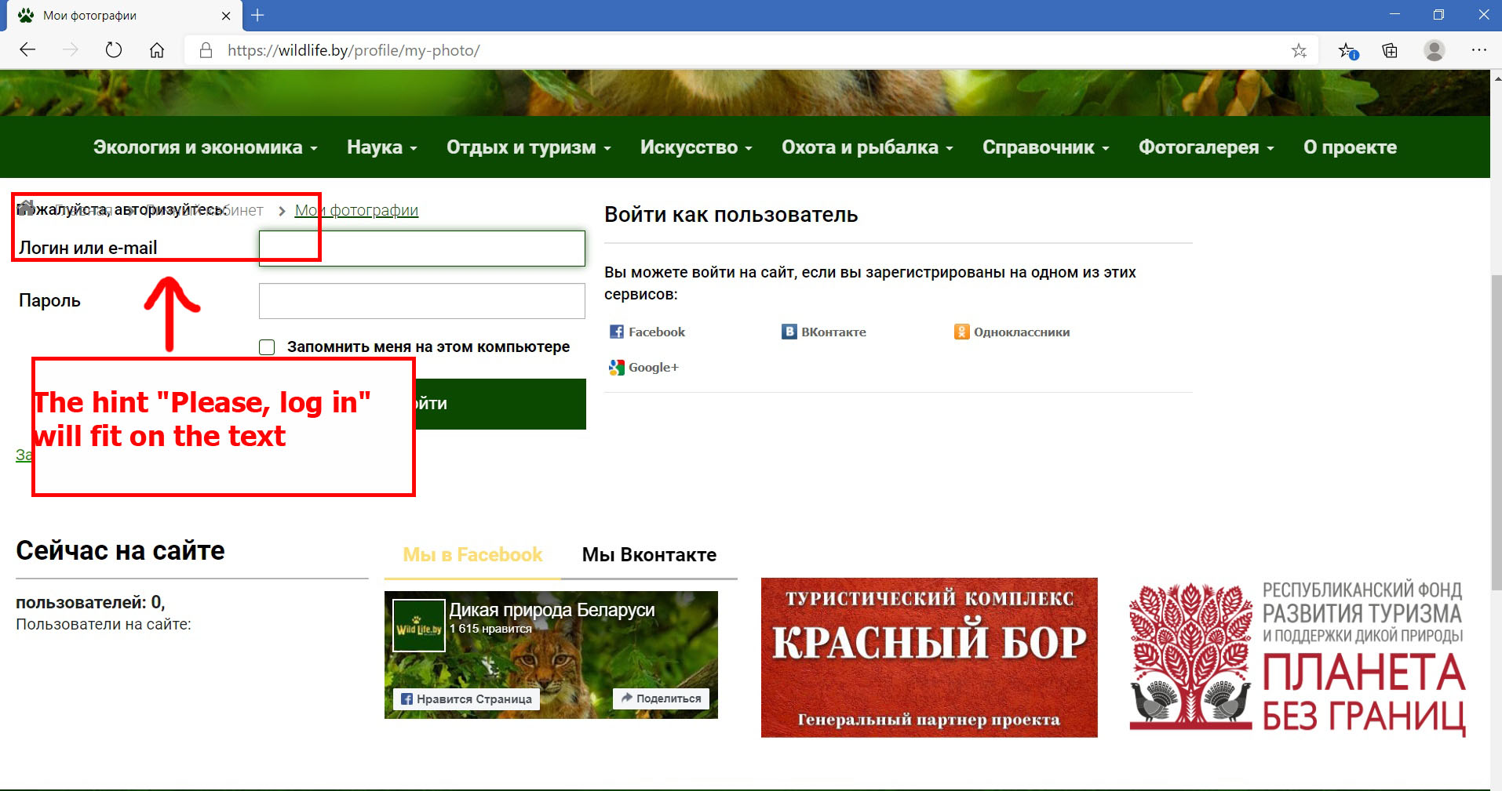

**My blog: the hint will fit on the text.**

**Steps to reproduce:**

1. Open the link <https://wildlife.by/profile/my-blog/>.
2. Pay attention to the hint "Please, log in"

**Actual result:** The hint "Please, log in" will fit on the text (screenshot 10.1).

**Expected result:** The hint should be below.

**Environment:**

1. Os: Windows 10;
2. Browser: Internet Explorer 11.1139.18362.0, Google Chrome 86.0.4240.183, Yandex 20.9.3.136, Microsoft Edge 86.0.622.63

**Severity:** Trivial.

**Priority:** High.

**Attachment:**

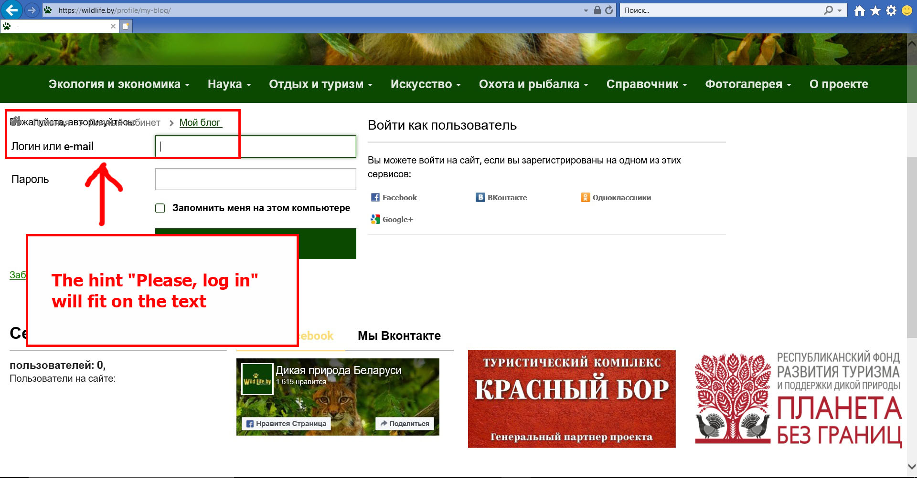

**Blogs: The blog is displayed not from the right edge, but from the middle.**

**Steps to reproduce:**

1. Open the home page.
2. Choose "Science".
3. Scroll down and pay attention to the blog.

**Actual result:** The blog is displayed not from the right edge, but from the middle. (screenshot 11.1).

**Expected result:** The blog should be crawled starting from the left edge (screenshot 11.2).

**Environment:**

1. Os: Windows 10;
2. Browser: Internet Explorer 11.1139.18362.0, Google Chrome 86.0.4240.183, Yandex 20.9.3.136, Microsoft Edge 86.0.622.63

**Severity:** Trivial.

**Priority:** Medium.

**Attachment:**

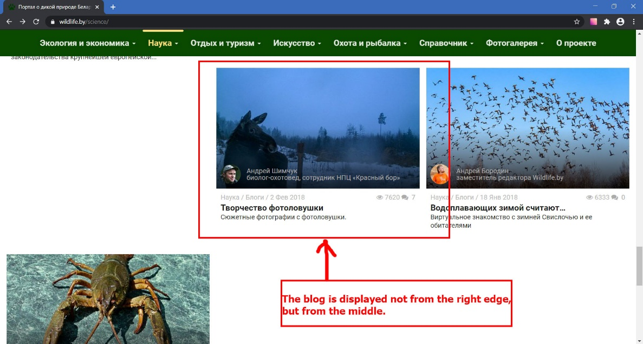e